**“E-Farmer”**

**D Sree Bhargav Reddy1, M Abhiram Reddy2, K Babu3,**

**under the guidance of Prof Raghavendra. M. Devadas 4**

*Student, BTech (Computer Science and Engineering), Presidency University, Bangalore, India1*

*Student, BTech (Computer Science and Engineering), Presidency University, Bangalore, India2*

*Student, BTech (Computer Science and Engineering), Presidency University, Bangalore, India3*

*Professor, Computer Science & Engineering Department, Presidency University, Bangalore, India4*

*dbhargav098@gmail.com1*

*abiramreddyabiramreddy@gmail.com2*

*babukodidala9958@gmail.com3*

*raghudevdas@gmail.com4*

**ABSTRACT:** The agriculture sector plays a crucial role in our country, but farmers often face challenges in selling their products directly without the involvement of middlemen. To address this issue, we have come up with a great idea that allows farmers to sell their products directly to customers at a fixed price, without any commissions charged by intermediaries. This is an e-commerce website that involves three types of roles: an admin who manages the website, farmers who sell and deliver the products, and users who place orders on the website.

**INTRODUCTION:** E-farming is beginning to have a major impact on the agricultural sector. The way people go about purchasing agricultural products is of great concern. Most of the time customers have to travel far distances to get agricultural products and getting the right quality is not ensured.

Even after all the hard work and the production done by the farmers, in today’s market, the farmers are cheated by the Agents, leading to a great loss. This project aims to help farmers as well as customers for buying and selling agricultural products directly using a computerized approach. The "E-commerce Website for Grocery Retail" project introduces a user-friendly online platform designed to revolutionize grocery shopping. Providing a diverse array of grocery products, the website prioritizes convenience through an intuitive interface, personalized user accounts, and advanced search features. Security is paramount, with robust payment gateways ensuring safe financial transactions and data privacy.

Efficiency is a key focus, with streamlined order processing, real-time inventory management, and reliable delivery options enhancing the overall customer experience. Embracing contemporary e-commerce trends, the platform boasts a responsive design, catering to users across various devices. This initiative aims to bridge the gap between traditional and modern grocery shopping, catering to the fast-paced lifestyles of today's consumers.

The project's vision extends beyond facilitating transactions, aiming to create a reliable, secure, and efficient digital space for users to meet their grocery needs. The integration of technology not only enhances the accessibility of the platform but also contributes to a seamless, end-to-end shopping experience. Ultimately, this e-commerce website seeks to redefine grocery retail by combining the convenience of online shopping with the reliability and diversity essential for a comprehensive grocery shopping experience.

These websites revolutionize the grocery shopping experience by offering consumers a convenient and efficient platform to purchase a wide array of groceries. With an intuitive user interface, these websites ensure easy navigation and quick access to a comprehensive catalog that includes fresh produce. The design prioritizes responsiveness across different devices, allowing customers to seamlessly browse and shop using smartphones or tablets. The ordering process is streamlined, featuring an efficient cart system and a straightforward checkout process with multiple secure payment options. Personalization is integrated through user accounts, providing customers with order history and personalized recommendations based on their preferences. To bolster security, these platforms implement SSL certificates and secure payment gateways. Inventory management is optimized with real-time updates to prevent out-of-stock issues, and delivery logistics are meticulously managed to meet promised timelines, complete with tracking capabilities for customer convenience. Promotions, discounts, and loyalty programs further incentivize customer engagement, while reviews and feedback contribute to transparency and trust-building. Overall, e-commerce grocery websites prioritize customer satisfaction through a seamless, secure, and personalized shopping journey.

**LITERATURE REVIEW**

**1.) E-farmer Management System for Agrarian Service Centre in Sri Lanka (**Karunarathna, KNNS Vida agama, DU 2015**)**

“The E-farmer Management System (EFMS) would be constructed with Web-based technologies and the C# programming language to give users integration and accessibility. The system employs a centralized database system, via which all clients can access the EFMS network.

This study used both quantitative and qualitative methods. Document reviews were utilized to uncover quantitative values. Interviews, observations, and case studies were employed to disclose qualitative values. EFMS is the greatest answer for farmers who are frustrated by the inefficiency and lack of communication of Sri Lanka's agrarian service centers. It will usher in a new era in Sri Lanka's agricultural economy.” [[1](../Downloads/1.pdf)]

**2.) E-Farmer Self Service(Tharani K ,Varsini N ,Revathi K ,Sri Karthick M)**

“The website will guide the farmers to access new farming techniques and compare the current market rate of different products, the total sales, and the earned profit for the sold products. The website builds a platform for farmers to ensure greater profitability through direct farmer-to-farmer, farmer-agent, and farmer-to-customer communication. The website will act as a unique and secure way to perform agro-marketing. This project allows viewing of various products available and enables users to purchase desired products instantly by online payment.” [[2](../Downloads/2.pdf)]

**3.) E-Farmer(D Novianti , Dewi Anjani 2020)**

“A piece of software Testing is one of the stages in the development of an application where an incorrectly constructed test device would most likely hurt the resultant program. E-farmer is an android-based application that allows a farmer to determine the profit yield for each crop. The goal of testing E-farmer is to determine the error rate in the software. So that by testing this application, it is hoped that the application created complies with the application'sfunction and purpose. This test uses the Black-box Testing method in conjunction with the Boundary Value Analysis approach. The findings of this study's testing suggest that the application has an 88.89% success rate. There are three fields.” [[3](../Downloads/3.pdf)]

**4.) E-Farmer (Abdul Mufti , Dewi Anjani ,D Novianti 2018)**

“This study aimed to find out the influence of the promotional mix on sales levels with the study on farmers to support the sale of agricultural output. The application of E-commerce E-Farmer ' For Android ' is a media promotion and information is expected to meet the needs of farmers to market the results of their farms. This research uses the method of surveying respondents with the farmers who use the application e-commerce e-farmer ' for Android '. Testing is done using simple regression analysis and test F to do a test of the hypothesis.

The results obtained are the promotion of E-Commerce applications using ' E-Farmer for Android "effect simultaneously against the level of sales.” [[4](../Downloads/4.pdf)]

**5.) E-Farmer Management System for Empowering Sri Lankan Small-Scale Agriculture-Based Producers (KPP Sandareka , RMM Pradeep , MPL Perera , N.Wedasinghe 2020)**

“According to the Ministry of Rural Development, the major goals of Dedicated Economic Centers are to ensure farm producers earn appropriate prices for their goods by offering a targeted market and providing a chance for small-scale producers to reduce transportation costs and waste. Make it possible for wholesalers to buy fresh fruits and vegetables directly from producers. Encourage the business community by making available a competitive marketing environment.

Traders in bulk. Make it possible to supply area-specific agricultural products to consumers around the island, and make it possible for people to purchase food items at reduced costs. Marketing agricultural products differs from other types of marketing.” [[5](../Downloads/5.pdf)]

**6.) E-BUSINESS TO SUPPORT SALES OF FARMER CROPS BASED ON MOBILE APPLICATIONS (Muhammad Aiman Abdul Hafizh , Ari Purno Wahyu Wibowo 2023)**

“The agricultural sector is essential because it is the leading sector and supports the Indonesian economy. Sukapura Village is one of the producers of plant products in the Kertasari District. On the other hand, most of the farmers experienced problems, and several obstacles emerged, such as the accumulation of harvests that were sold at low prices, which resulted in losses, and the difficulty of distribution because it was pretty complicated. Of course, this situation must be improved so that people can enjoy Indonesian agricultural products. One of them is building an android-based application "Petani Sejahtera" which is specifically made as an alternative to make it easier for farmers.

It can break the distribution chain of agricultural products. You can directly contact the courier who has collaborated with the manager by displaying information on product price lists, farmers' products, and harvested products, which will later be distributed during the main harvest period. So that later, farmers will find it easier to see the products planted and not have to think about how to distribute the products. The purpose of making this "Petani Sejahtera" Application is to help farmers more easily distribute their products to various suppliers, so there is no accumulation of harvest yields.” [[6](../Downloads/6.pdf)]

**OBJECTIVES**

1.) Redefine the traditional grocery shopping experience by introducing an innovative and efficient online platform that seamlessly integrates with modern consumer lifestyles.

2.) Streamline order processing, inventory management, and delivery logistics to optimize operational efficiency, ensuring timely and reliable delivery of a diverse range of fresh grocery items.

3.) Curate a comprehensive product range, from farm-fresh produce to pantry staples, catering to the diverse needs and preferences of consumers, and providing a one-stop solution for their grocery requirements.

**EXPERIMENTAL DETAILS/METHDOLOGY**

**HARDWARE REQUIREMENTS**

This section gives the details and specifications of the hardware on which the system is expected to work.

|  |  |
| --- | --- |
| Processor | Intel Core |
| RAM | 4 GB DDR4 RAM |
| Monitor | 14, Color |
| ROM | 40 GB |
| Keyboard | Standard 102 keys |
| Mouse | Optical |

Table 1: Hardware Requirements

**SOFTWARE REQUIREMENTS**

This section gives the details of the software that is used for the development.

|  |  |
| --- | --- |
| Environment | eclipse |
| Front-End | Html, Css |
| Back-End | My SQL Server (Java) |
| Coding Language | Full Stack Web Development |
| Operating System | Windows 11 |
| Browser | Google Chrome |

Table 2 : Software Requirements

**ARCHITECTURE DIAGRAM**

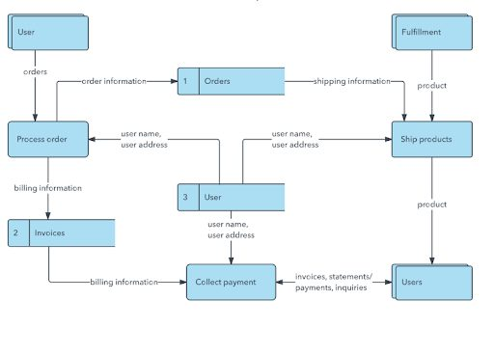

Figure 1: Architecture Diagram

**PROPOSED METHOD**

1.) The proposed methods for Farmer’s Mart include a user-centric design for an intuitive interface and streamlined navigation.

2.) A comprehensive product curation system will manage a diverse range of groceries.

3.) Efficient order processing will be achieved with real-time inventory tracking.

4.) Data analytics will optimize inventory management for timely restocking.

5.) Responsive customer support will address queries promptly. Continuous innovation and updates will ensure the platform remains competitive.

6.) Sustainable practices, like eco-friendly packaging, will be explored.

7.) Rigorous quality assurance testing will guarantee platform stability and reliability.

**EXPECTED OUTCOME**

1.) The Farmer’s Mart project envisions delivering an intuitive and secure online grocery shopping platform, simplifying user navigation, and ensuring data privacy.

2.) The outcome anticipates efficient order processing, real-time inventory tracking, and optimized inventory management for timely restocking.

3.) By focusing on sustainability and quality assurance, the project aims to provide a competitive and reliable solution for consumers seeking diverse and eco-friendly grocery options.

4.) The project aspires to reshape the digital grocery retail landscape, offering a trustworthy, responsive, and environmentally conscious platform.

5.) Improved Agricultural Supply Chain Efficiency.

6.) Environmental Impact and Sustainable Practices.

**IMPLEMENTATION**

**LOGIN & REGISTRATION PAGE’S**

Users of the system should be accessed through the login function. Users already should have username passwords to log into the system.

The new Users Tour farmers can use the registration Page for the login Credentials.

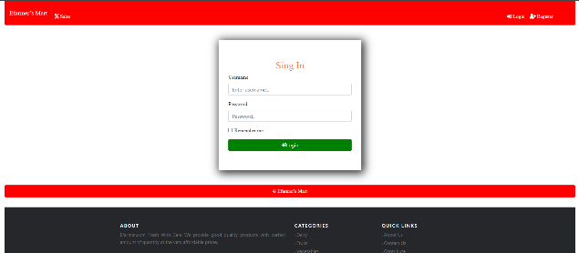

Figure 2 : Login Page

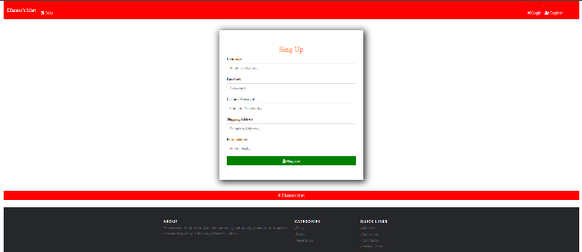

Figure 3: Registration page

**ADMIN PAGE**

Every primary user must register through the system by creating a user account. Then a user ID will be automatically generated according to the user type through the system.

An admin can change the rules of the user who is new website.

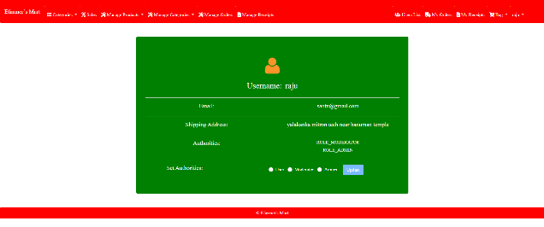

Figure 4: Admin profile

**FARMER’S PAGE**

And farmers get their products according to their items which they are selling and fix the rate according to the Item depending upon Users who is Ordering from the Website.

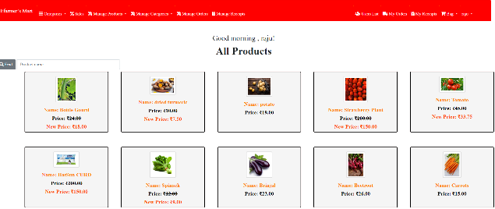

Figure 5: Seller-Side Home Page

These are the ordered page and Receipt page and product adding page according to farmers end as shown below.

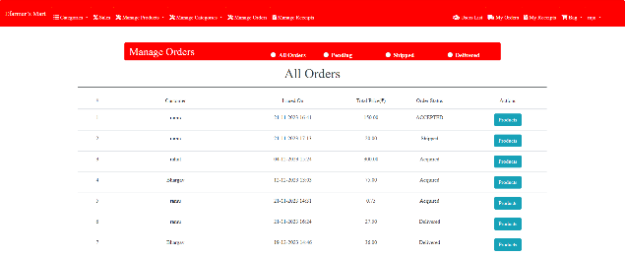

Figure 6: Order page

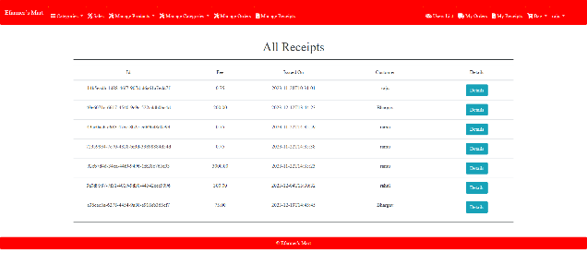

Figure 7: Receipt page

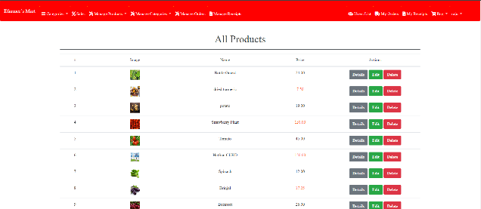

Figure 8: Products Adding page

**USER PAGE**

Users are the customers where there will be order in the items from the Website at the cheaper place directly from the Farmers.

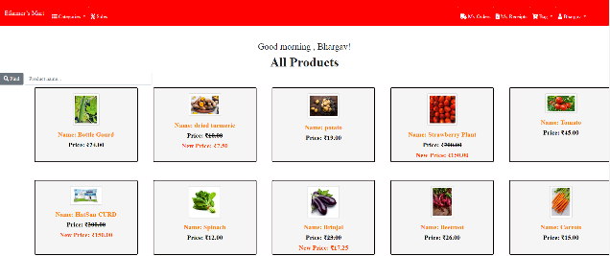

Figure 9: User-Side Home Page

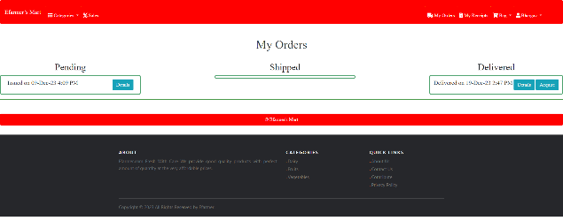

Figure 10: User-Side Order Page

**ACKNOWLEDGEMENT**

We would like to thank Dr. Raghavendra M Devadas of the Computer Science and Engineering Department for inspiring us to complete this project.

**CONCLUSION**

In conclusion, the E-Farmer e-commerce website project holds great potential for transforming the agricultural landscape. By leveraging digital technologies, E-Farmer aims to empower farmers, enhance their access to essential products, and contribute to the overall development of the agricultural sector**.**

Farmer's Mart is prepared to disrupt online grocery retail by emphasizing user-centric design, extensive product selection, and solid security measures. The simplified approach keeps the emphasis on rapid order processing, real-time inventory management, and responsive customer service. Farmer's Mart wants to transform the digital grocery shopping experience, delivering a dependable and ecologically conscientious platform for modern consumers, with an uncompromising commitment to innovation, sustainability, and quality assurance.

**REFERENCES**

**1.)** Karunarathna, K. N. N. S., & Vidanagama, D. U. (2015). E-farmer Management System for Agrarian Service Centre in Sri Lanka.

**2.)** Tharani, K., Varsini, N., & Revathi, K. (2019). E-Farmer Self Service. *South Asian Journal of Engineering and Technology*, *8*(2), 203-204.

3.) Novianti, D., & Anjani, D. (2020). Pengujian Aplikasi E-FARMER dalam Perhitungan Keuntungan dengan Metode Blackbox Testing Boundary Value Analysis. *Jurnal Nasional Informatika (JUNIF)*, *1*(2), 77-81.

**4.)** Novianti, D. (2018). Pengaruh Bauran Promosi Terhadap Tingkat Penjualan Petani Pada Aplikasi E-commerce ‘E-farmer for Android'. *Rabit*, *3*(2), 60-68.

5.) Sandareka, K. P. P., Pradeep, R. M. M., Wedasinghe, N., & Perera, M. P. L. E-Farmer Management System for Empowering Sri Lankan Small-Scale Agriculture-Based Producers.

**6.)** Hafizh, M. A. A., & Wibowo, A. P. W. (2023). E-BUSINESS TO SUPPORT SALES OF FARMER CROPS BASED ON MOBILE APPLICATIONS. *Jurnal Darma Agung*, *31*(1), 18-31.